**Database Application Development**

**CSC317 Database Systems II**

**Professor: Dr. Kurt Diesch**

**By Odiscious Dozier**

**Trident University**

**CASE 03 - Java and DBMS II**

**Exercise**

5.1.1 Creating a JavaBean in JDeveloper

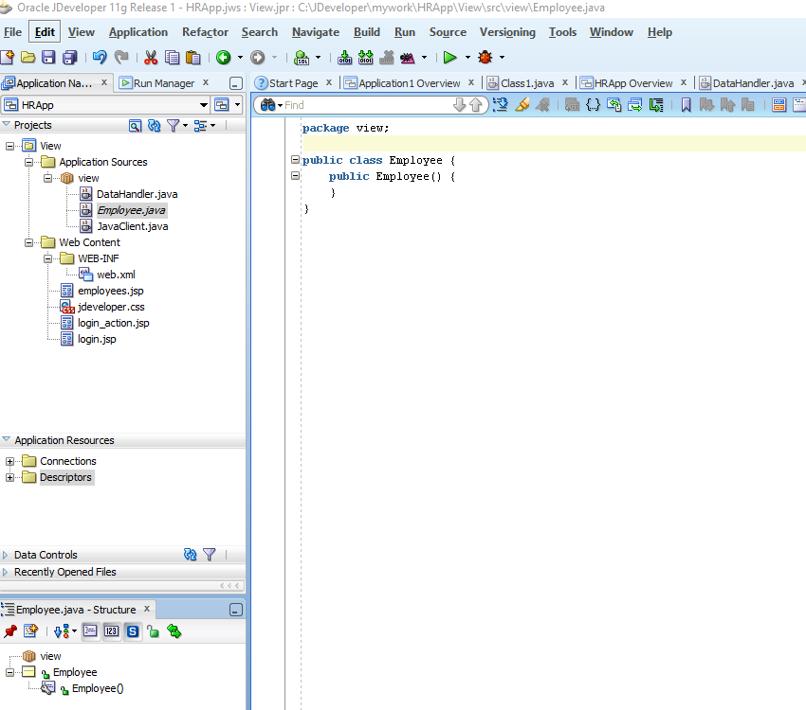

### 5.1.2 Defining the JavaBean Properties and Methods

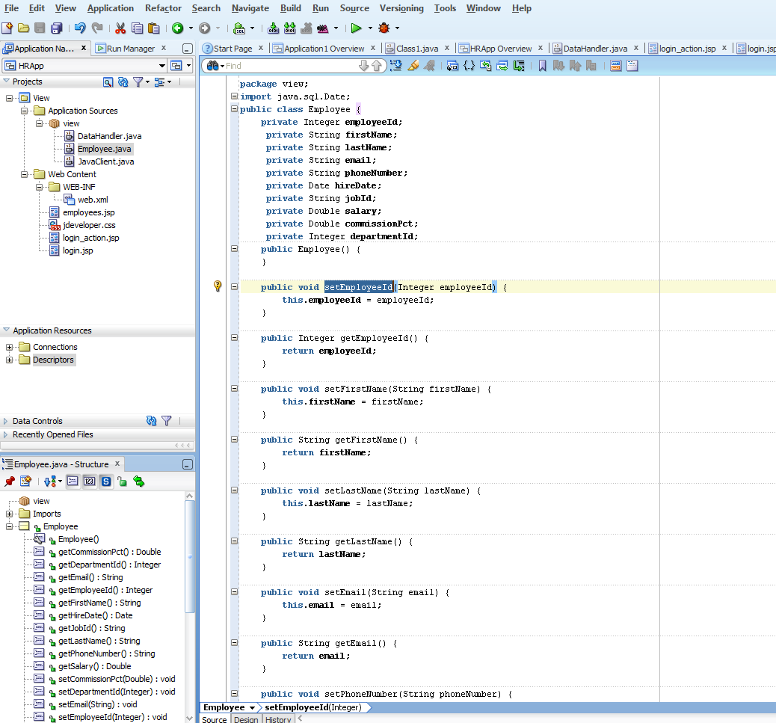

## **5.2 Updating Data from a Java Class**

1. “Create a method that finds a particular employee row. This is used to display the values for a particular employee on an edit page.
2. Create a method that takes the updated employee data from the bean and updates the database.
3. On the main application page, in every row of employee data, include a link that enables a user to edit the data for that employee. The links take the user to the**edit.jsp** file with the data for that employee displayed, ready for editing.
4. Create a JSP page called **edit.jsp**, that includes a form and a table to display all the data of a single employee and enables a user to change the values.
5. Create a JSP page that processes the form on the **edit.jsp** page, writes the updated values to the **Employee.java** bean and calls the **updateEmployee**method” (“5 Updating”, 2016).

### 5.2.1 Creating a Method to Identify an Employee Record

if ( salary != null &&

!salary.equals( oldEmployee.getSalary().toString() ) ) {

if ( columns.length() > 0 ) {

columns.append( ", " );

}

columns.append( "salary = '" + salary + "'" );

} //The tutorial forgot to add the last curly brace in this code segment

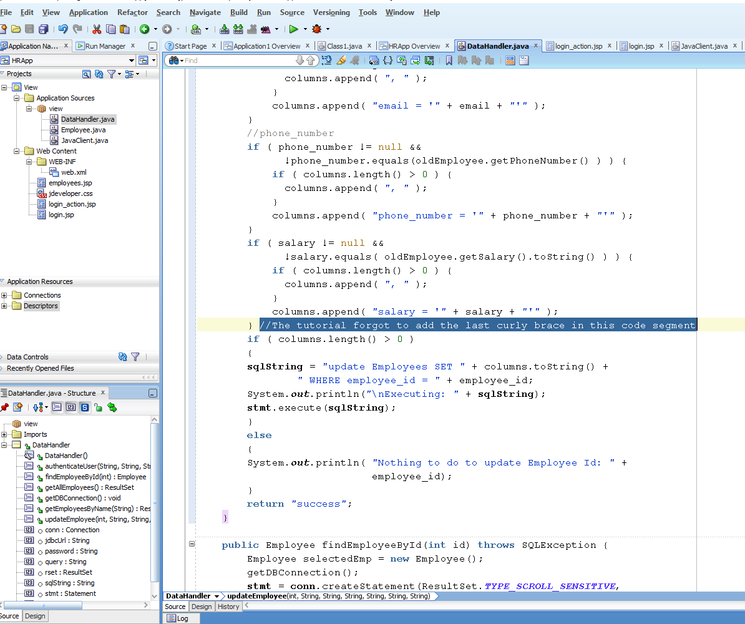

Compilation completed with 0 errors

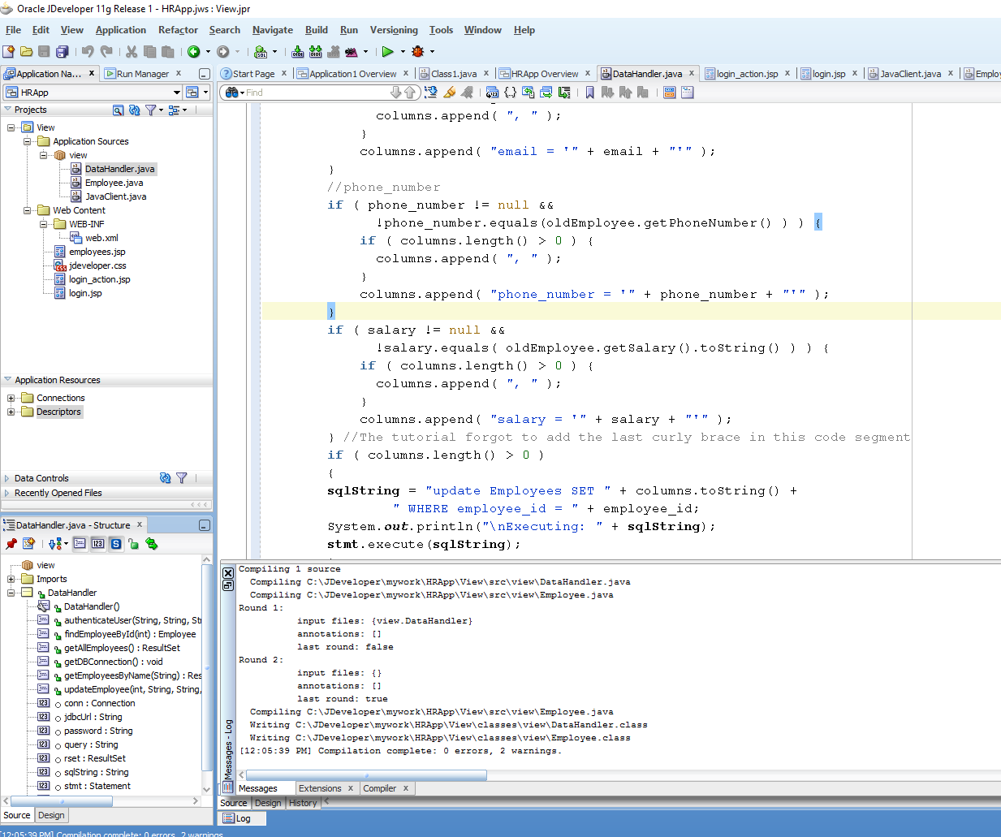

Job_id was skipped in the tutorial

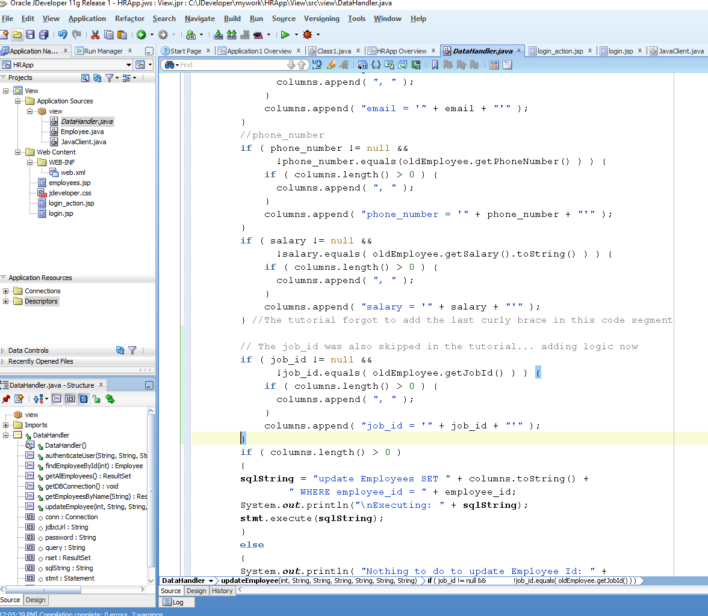

### 5.2.3 Adding a Link to Navigate to an Update Page

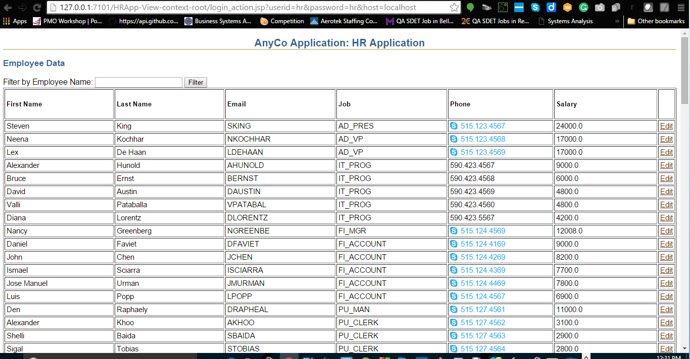

### 5.2.4 Creating a JSP Page to Edit Employee Data

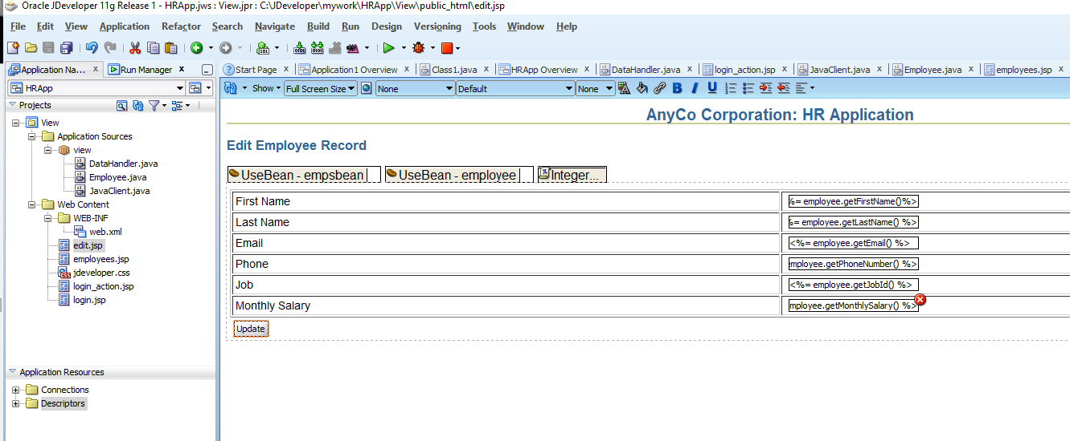

### 5.2.5 Creating a JSP Page to Handle an Update Action

REFERENCES

5 Updating Data. (2016). Retrieved March 07, 2016, from <http://docs.oracle.com/cd/E17781_01/appdev.112/e18805/upddata.htm#TDPJD186>